Assignment 6 -20 May

Python Basic – 1

**Q.1. What are keywords in python? Using the keyword library, print all the python keywords.**

Keywords in Python are reserved words that cannot be used as ordinary words in program. All the keyword has a specific meaning and usage in Python programming. Keywords cannot be changed/immutable and are also case sensitive.

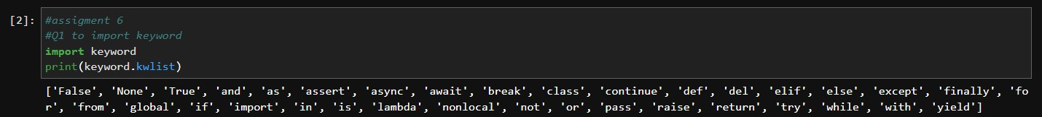

**Q2. What are the rules to create variables in python?**

a.Variable name must start with a letter(capital or small) or the underscore.

b.Variable name cannot start with a number.

c.Variable name can only contain alpha-numeric characters or underscores.

d.Variables cannot be keywords

e.Variable names are case-sensitive

**Q.3. What are the standards and conventions followed for the nomenclature of variables in**

**python to improve code readability and maintainability?**

Must be grammatically correct variable names. To use a lowercase single letter, word, or words and to separate words with underscores to improve readability. Start each word with a capital letter.

Variables must start with a Letter (A-Z) or an underscore ("_"), followed by more letters or numbers. Python is case sensitive.

**Q.4. What will happen if a keyword is used as a variable name?**

It will throw error of invalid syntax

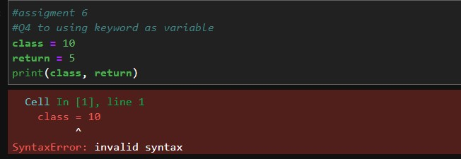

**Q.5. For what purpose def keyword is used?**

“def” keyword is used to define a function. It is used as creating user defined function

**Q.6. What is the operation of this special character ‘\’?**

The backslash "\" is a special character called "escape" character. Used in representing certain characters like "\t" is a tab and "\n" is a newline

**Q.7. Give an example of the following conditions:**

**(i) Homogeneous list**

Bakery = [“puff”, “cake”,”cookies”]

**(ii) Heterogeneous set**

List22 = [“apple”, 3, 9.8, [1, 2] ]

**(iii) Homogeneous tuple**

Fruits_tuple = (“apple”, “banana”, “cheery”)

**Q.8. Explain the mutable and immutable data types with proper explanation & examples.**

a. Mutable data types are where their elements can be changed (added, modified, or deleted) after they are created. Lists are mutable.

Vegiee = [“ brinjal”, ”carrot”, “beans”]

Here I can add, modify or delete the elements in list which wont throw error, like

Vegiee = [“broccoli”, “carrot”]

Print(Vegiee)

The print above will not throw any error

b. Immutable data types are where their elements cannot be changed (added, modified, or deleted) after they are created. Tuple are immutable.

Vegiee = (“ brinjal”, ”carrot”, “beans”)

Here I cannot add, modify or delete the elements in tuple which will throw error, like

Vegiee = (“broccoli”, “carrot”)

Print(Vegiee)

The print above is not possible and it will throw error

**Q.9. Write a code to create the given structure using only for loop.**

**\***

**\*\*\***

**\*\*\*\*\***

**\*\*\*\*\*\*\***

**\*\*\*\*\*\*\*\*\***

**Q.10. Write a code to create the given structure using while loop.**

**|||||||||**

**|||||||**

**|||||**

**|||**

**|**